SHEAR STRESS IN BEAM DUE TO TRANSVERSE LOADS
A transverse load applied to a beam will result in normal stress and shear stress in any given cross section. The normal stresses are caused by the bending moment $M$ in that section and the shear stress by the shear force $V$ | 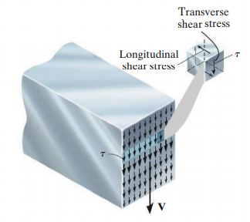 | 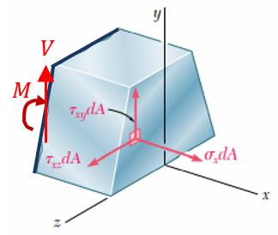
Due to the complimentary property of shear, an equal shear stress will be acting in the horizontal planes also. This can be seen in the following pictures below. Since the top and bottom surfaces are free of any shear force, the shear force on the cross section near to the top and bottom surface should also be zero (satisfying the boundary conditions).
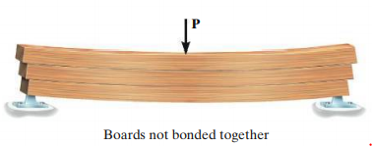 | 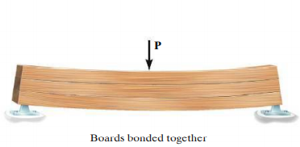
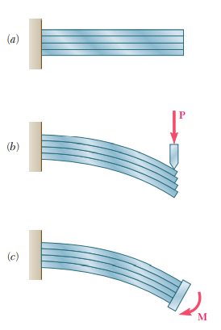 | 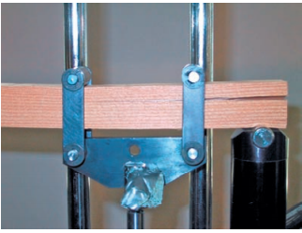
Consider a prismatic beam $AB$ with a vertical plane of symmetry that supports various transverse loads as shown. At a distance $x$ from A, an element $CC’D’D$ of length $dx$ extending across the width is cut out from the beam. The bottom surface of the element is at a distance $y$ from the neutral axis. | 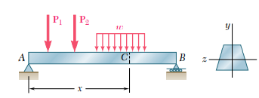
 | 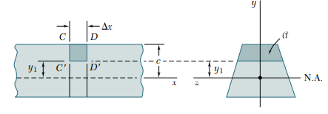
Considering the force equilibrium in the horizontal direction, we can write  $$\int_{o}{σ_{c} dA}+V-\int_{o}{σ_{D} dA}=0$$ | 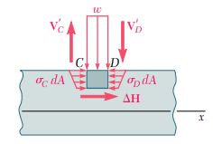  $$b$$  $$V=τ .b dx$$  $$w$$  $$dx$$  $$V$$
$$\int_{y=y_{1}}^{y=c}{\frac{M_{z}^{C}}{I_{zz}}ydA}+V-\int_{y=y_{1}}^{y=c}{\frac{M_{z}^{D}}{I_{zz}}ydA}=0$$
$$τ b.dx=\int_{y=y_{1}}^{y=c}{\frac{M_{z}^{D}-M_{z}^{C}}{I_{zz}}} ydA ≫ ≫ τ=\frac{1}{I_{zz}b}\left(\frac{dM}{dx}\right)\int_{y=y_{1}}^{y=c}{y dA}≫τ=\frac{V}{I_{zz}b}{\left[A'\overline{y}'\right]}_{y=y_{1}}^{y=c}$$
$$τ=\frac{VQ}{bI_{zz}}$$
${\left[A'\overline{y}'\right]}_{y=y_{1}}^{y=c}$is the first moment of the cross-sectional area from $y_{1} to c (outer surface)$ with respect to the neutral axis.

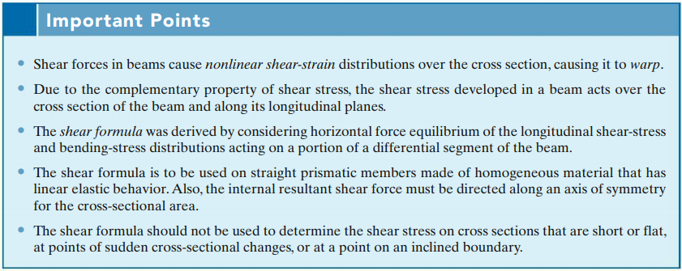

#Example 1  Determine the shear stress distribution across the rectangular cross section of a beam |  |  | 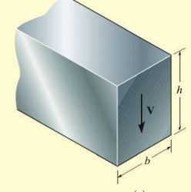  $$y$$
Consider a horizontal section of the beam at a distance y from the neutral axis. The depth of the element is $\left(\frac{h}{2}-y\right)$ and the cross-sectional area of the element $A'=b\left(\frac{h}{2}-y\right)$. The centroid of this area from the y-axis,  $${\overline{y}}^{'}=y+\frac{\frac{h}{2}-y}{2}=\frac{y}{2}+\frac{h}{4}=\frac{1}{2}\left(\frac{h}{2}+y\right)$$ |  |  | 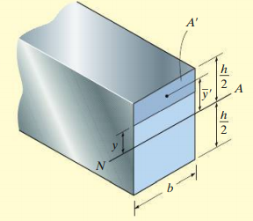  $$z$$  $$x$$
$$A^{'}{\overline{y}}^{'}=b\left(\frac{h}{2}-y\right)\frac{1}{2}\left(\frac{h}{2}+y\right)=\frac{b}{2}\left(\frac{h^{2}}{4}-y^{2}\right)$$  The shear stress on this horizontal plane  $$τ=\frac{V}{I_{zz}b}A^{'}{\overline{y}}^{'}=\frac{V}{\left(\frac{bh^{3}}{12}\right)b}× \frac{b}{2}\left(\frac{h^{2}}{4}-y^{2}\right)=\frac{6V}{bh^{3}}\left(\frac{h^{2}}{4}-y^{2}\right)$$  The shear stress distribution is parabolic.  $$τ=\left(\frac{V}{bh}\right)\left(\frac{3}{2}-\frac{{6y}^{2}}{h^{2}}\right)\left\{\begin{matrix}y=±\frac{h}{2}, τ=0 \\ y=0, τ=1.5 \frac{V}{A}\end{matrix}\right\}$$ |  |  | 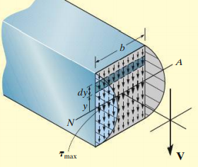
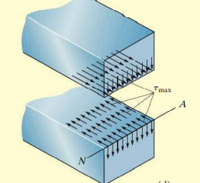 | 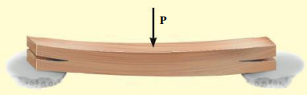 | 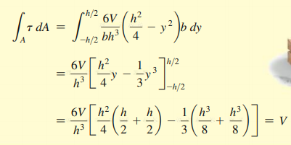

#Example 2  Beam AB is made of three planks glued together and is subjected, in its plane of symmetry, to the loading shown. Knowing that the width of each glued joint is 20 mm, determine the average shearing stress in each joint n-n of the beam | 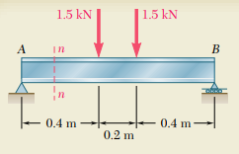 |  |  | 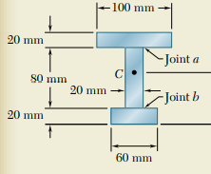
$$ΣF_{x}=0 ≫≫ X_{A}=0$$  $$ΣM_{A}=0≫≫$$  $$R_{B}×1m- 1.5 kN×0.4m-1.5 kN×0.6m=0≫ R_{B}=1.5 kN$$  $$ΣF_{y}=0 ≫≫ R_{B}+Y_{A}-1.5 kN-1.5 kN=0 ≫≫Y_{A}=1.5 kN$$ |  |   $$Y_{A}$$  $$X_{A}$$  $$R_{B}$$
Section n-n  $$Y_{A}-V=0≫≫V=1.5 kN$$  $A_{i}$ ${mm}^{2}$ $y_{i}$ mm $$A_{i}y_{i}$$  1. $$20×100=2000$$ $$110$$ $$220000$$  2. $$20×80=1600$$ $$60$$ $$96000$$  2. $$20×60=1200$$ $$10$$ $$12000$$  $${ΣA}_{i}=4800$$ $${ΣA}_{i}y_{i}=328000$$  $$\overline{y}=\frac{{ΣA}_{i}y_{i}}{{ΣA}_{i}}=68.3 mm$$ |  |  |   $$M$$  $$V$$  $$X_{A}$$  $$R_{B}$$  $$Y_{A}$$
Moment of inertia of the cross-section about the neutral axis (centroidal z-axis)  $$I_{zz}=\left\{\frac{100×{20}^{3}}{12}+2000×{(110-68.3)}^{2}\right\}+\left\{\frac{20×{80}^{3}}{12}+1600×{(68.3-60)}^{2}\right\}+\left\{\frac{60×{20}^{3}}{12}+1200×{(68.3-10)}^{2}\right\}$$  $$I_{zz}=\left\{66666.7+3477780\right\}+\left\{853333.3+110224\right\}+\{40000+4078668\}$$  $$I_{zz}=8626.7×{10}^{3} {mm}^{4}=8.63×{10}^{-6} m^{4}$$ |  |  |   $$68.3mm$$
The shear stress on the cross section of top flange  $$31.7mm$$  $$A^{'}=0.1(0.0517-y) ≪≫ {\overline{y}}^{'}=\frac{(0.0517+y)}{2}$$  $$A'{\overline{y}}^{'}=0.05({0.0517}^{2}-y^{2})$$  At the top of the flange, $y=0.0517 m$. Therefore, $τ=\frac{V}{I_{zz}b}A^{'}{\overline{y}}^{'}=0$  At the bottom of the top flange, $y=0.0317 m≫≫≫A^{'}{\overline{y}}^{'}=8.34×{10}^{-5}$  $$τ=\frac{V}{I_{zz}b}A^{'}{\overline{y}}^{'}=\frac{1.5×{10}^{3}}{8.63×{10}^{-6} m^{4}×0.1 m}×8.34×{10}^{-5}=145 kPa$$ |  |  |  |  | $$neutral axis$$  $$51.7mm$$  $$y$$
Shear stress on the cross section of the web  $$A^{'}{\overline{y}}^{'}=\left(0.1×0.02\right)\left(0.417\right)+0.02\left(0.0317-y\right)\left(\frac{0.0317+y}{2}\right)$$  $$=8.34×{10}^{-5}+0.01({0.0317}^{2}-y^{2})$$ |  |  |  |  | $$neutral axis$$  $$y$$  $$31.7mm$$  $$51.7mm$$
Top of the web (junction), $y=0.0317 m≫≫≫A^{'}{\overline{y}}^{'}=8.34×{10}^{-5}$
$$τ=\frac{V}{I_{zz}b}A^{'}{\overline{y}}^{'}=\frac{1.5×{10}^{3}}{8.63×{10}^{-6} m^{4}×0.02 m}×8.34×{10}^{-5}=725 kPa$$
At the neutral surface,$y=0≫≫≫A^{'}{\overline{y}}^{'}=9.345×{10}^{-5}$
$$τ=\frac{V}{I_{zz}b}A^{'}{\overline{y}}^{'}=\frac{1.5×{10}^{3}}{8.63×{10}^{-6} m^{4}×0.02 m}×9.345×{10}^{-5}=812 kPa$$
At the bottom of the web, $y=-0.0483m≫≫≫A^{'}{\overline{y}}^{'}=7.012×{10}^{-5}$
$$τ=\frac{V}{I_{zz}b}A^{'}{\overline{y}}^{'}=\frac{1.5×{10}^{3}}{8.63×{10}^{-6} m^{4}×0.02 m}×7.012×{10}^{-5}=609 kPa$$
Shear Stress on the bottom flange  $$A^{'}=0.06(0.0683-y) ≪≫ {\overline{y}}^{'}=\frac{(0.0683+y)}{2}$$  $$A'{\overline{y}}^{'}=0.03({0.0683}^{2}-y^{2})$$ |  | $$48.3mm$$  $$neutral axis$$  $$y$$  $$68.3mm$$  $$60mm$$
At the bottom of the flange, $y=-0.0683 m$.  Therefore, $τ=\frac{V}{I_{zz}b}A^{'}{\overline{y}}^{'}=0$  At the joint with the web,  $$y=-0.0483 m≫≫≫A^{'}{\overline{y}}^{'}=6.996×{10}^{-5}$$  $$τ=\frac{V}{I_{zz}b}A^{'}{\overline{y}}^{'}=\frac{1.5×{10}^{3}}{8.63×{10}^{-6} m^{4}×0.06 m}×6.996×{10}^{-5}$$  $$=203 kPa$$ | $$0$$  $$203 kPa$$  $$812 kPa$$  $$609 kPa$$  $$145 kPa$$  $$725 kPa$$  $$0$$

Exercise 1  A steel wide flange beam has the dimensions as shown. It carries a transverse shear force $V=80 kN$. Plot the shear stress distribution across the cross section of the beam |  | 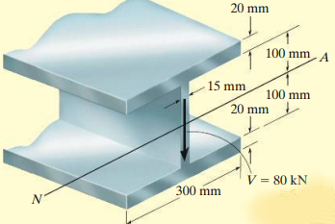
Exercise 2  Determine the shear stress distribution across the cross section of the beam at location a-a. | 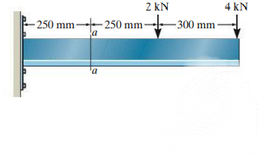 |  |  | 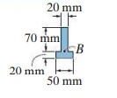
Exercise 3  A beam is made of three planks, $20mmx100mm$ in cross section, nailed together. Knowing that the spacing between nails is $25 mm$ and that the vertical shear in the beam is $V= 500 N$. determine the shearing force in each nail. |  |  | 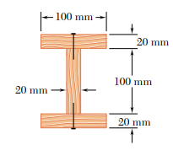

Elastic Strain Energy for various types of loading
- Axial | 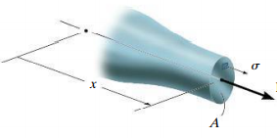  P |  | $$U=\int_{V}{\frac{{σ_{x}}^{2}}{2E} dV}=\int_{V}{\frac{P^{2}}{2EA^{2}} dV}$$
 |  |  | $$U=\int_{0}^{L}{\frac{P^{2}}{2AE} dx}$$
 | 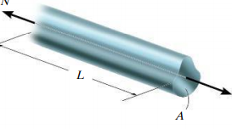  P |  | $$U=\frac{P^{2}L}{2AE}$$
- Torsion | 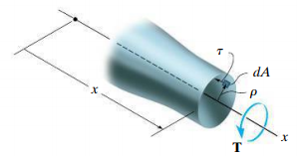 | $$U=\int_{V}{\frac{τ^{2}}{2G} dV}=\int_{V}{\frac{1}{2G}{\left(\frac{Tr}{J}\right)}^{2} dA dx}$$  $$U=\int_{V}{\frac{T^{2}}{2GJ^{2}}\left(\int{r^{2}dA }\right)dx}=\int_{0}^{L}{\frac{T^{2}}{2GJ}}dx$$
- Bending | 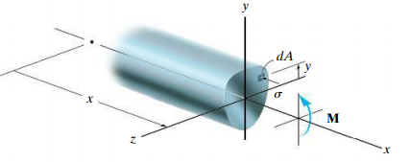 | $$U=\int_{V}{\frac{{σ_{x}}^{2}}{2E} dV}=\int_{V}{\frac{1}{2E}{\left(\frac{My}{I}\right)}^{2} dA dx}$$
 |  | $$U=\int_{0}^{L}{\frac{M^{2}}{2EI^{2}}\left(\int{y^{2}dA }\right)dx}=\int_{0}^{L}{\frac{M^{2}}{2EI}}dx$$
- Transverse shear | 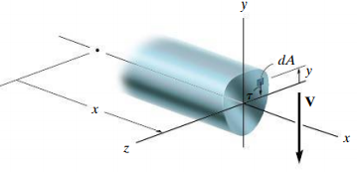 | $$U=\int_{V}{\frac{τ^{2}}{2G} dV}=\int_{V}{\frac{1}{2G}{\left(\frac{VQ}{It}\right)}^{2} dA dx}$$  $$U=\int_{0}^{L}{\frac{V^{2}}{2GI^{2}}\left(\int{\frac{Q^{2}}{t^{2}}dA }\right)dx}$$
 | Form factor  $$f_{s}=\frac{A}{I^{2}}\int{\frac{Q^{2}}{t^{2}}dA }$$ | $$U=\int_{0}^{L}{\frac{{f_{s}V}^{2}}{2GA}dx}$$

References
- Mechanics of Materials, 2/e, J. M. Gere & S. P.Timoshenko, CBS Publishers.
- Mechanics of Materials, 6/e, F.P. Beer & E. R. Johnston, McGraw Hill
- Engineering Mechanics of Solids, 2/e, E. P. Popov, Pearson Education Asia.
- Mechanics of Materials, 9/e, R. C. Hibbeler, Prentice Hall.

